4. Construct a scheduling program with C that selects the waiting process with
the smallest execution time to execute next.
PROGRAM:
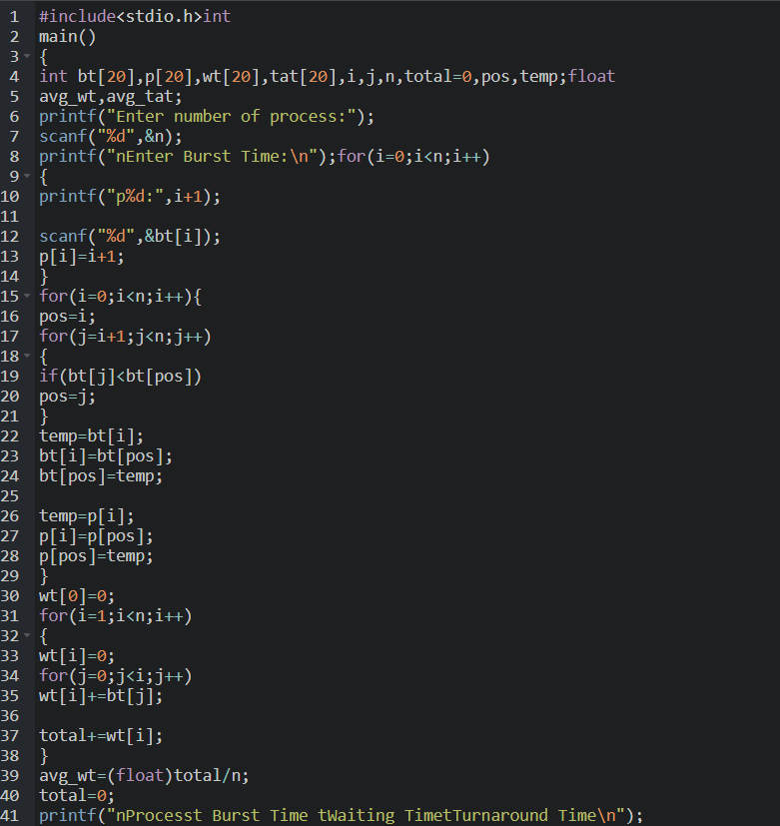
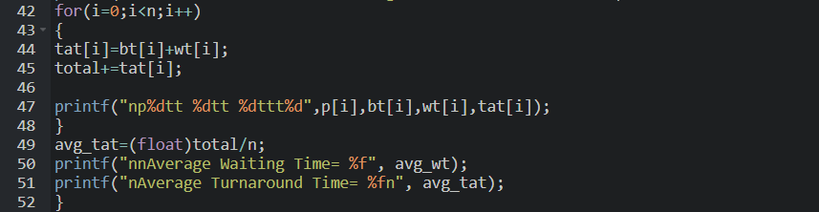

OUTPUT:
